**EXPERIMENT 8**

**AIM: Write a program which demonstrates React Router and single page applications.**

**CODE:**

**App.js:**

import React from 'react';

import { BrowserRouter as Router, Route, Routes } from 'react-router-dom';

import Navbar from './Navbar';

import Home from './pages/Home';

import Play from './pages/Play';

import Buy from './pages/Buy';

import './App.css';

function App() {

  return (

    <Router>

      <div className="App">

        <Navbar />

        <Routes>

          <Route path="/" element={<Home />} />

          <Route path="/play" element={<Play />} />

          <Route path="/buy" element={<Buy />} />

        </Routes>

      </div>

    </Router>

  );

}

export default App;

**Home.js:**

import React from 'react';

const Home = () => {

  return (

    <div style={{ backgroundColor: '#000', color: '#fff', minHeight: '100vh', textAlign: 'center', padding: '19rem' }}>

      <h1>Welcome to HellOfGames</h1>

    </div>

  );

};

export default Home;

**Play.js:**

import React from 'react';

import './GameList.css';

import residentEvil4 from './RE4R.jpg';

import residentEvil2 from './RE2R.jpg';

import godOfWar from './GOW.jpg';

import residentEVil8 from './RE8V.png';

import unchartedAmongTheives from './UAT.jpg';

import dyingLight from './DL.jpg';

import dyingLightTheFollowing from './DLF.jpg';

import homeSweetHome from './HSH.jpg';

import untilDawn from './UD.jpg';

const games = [

{ name: 'Resident Evil 4 (Remake)', image: residentEvil4 },

  { name: 'Resident Evil 2 (Remake)', image: residentEvil2 },

  { name: 'God Of War', image: godOfWar },

  { name: 'Uncharted Among Theives', image: unchartedAmongTheives },

  { name: 'Dying Light', image: dyingLight },

  { name: 'Dying Light: Following', image: dyingLightTheFollowing },

  { name: 'Resident Evil: Village', image: residentEVil8 },

  { name: 'Home Sweet Home', image: homeSweetHome },

  { name: 'Until Dawn', image: untilDawn }

];

const Play = () => {

  return (

    <div style={{ backgroundColor: '#000', color: '#fff', minHeight: '100vh', padding: '2rem', alignContent: 'center' }}>

      <h1>Play Games</h1>

      <div className="game-list">

        {games.map((game, index) => (

          <div key={index} className="game-item">

            <img src={game.image} alt={game.name} className="game-image" />

            <h2>{game.name}</h2>

          </div>

        ))}

      </div>

    </div>

  );

};

export default Play;

**Buy.js:**

import React from 'react';

import './GameList.css';

import residentEvil4 from './RE4R.jpg';

import residentEvil2 from './RE2R.jpg';

import godOfWar from './GOW.jpg';

import residentEVil8 from './RE8V.png';

import unchartedAmongTheives from './UAT.jpg';

const games = [

  { name: 'Resident Evil 4 (Remake)', image: residentEvil4 },

  { name: 'Resident Evil 2 (Remake)', image: residentEvil2 },

  { name: 'God Of War', image: godOfWar },

  { name: 'Uncharted Among Theives', image: unchartedAmongTheives },

  { name: 'Resident Evil: Village', image: residentEVil8 }

];

const Buy = () => {

  return (

    <div style={{ backgroundColor: '#000', color: '#fff', minHeight: '100vh', padding: '2rem' }}>

      <h1>Buy Games</h1>

      <div className="game-list">

        {games.map((game, index) => (

          <div key={index} className="game-item">

            <img src={game.image} alt={game.name} className="game-image" />

            <h2>{game.name}</h2>

          </div>

        ))}

      </div>

    </div>

  );

};

export default Buy;

**OUTPUT:**

**Home**

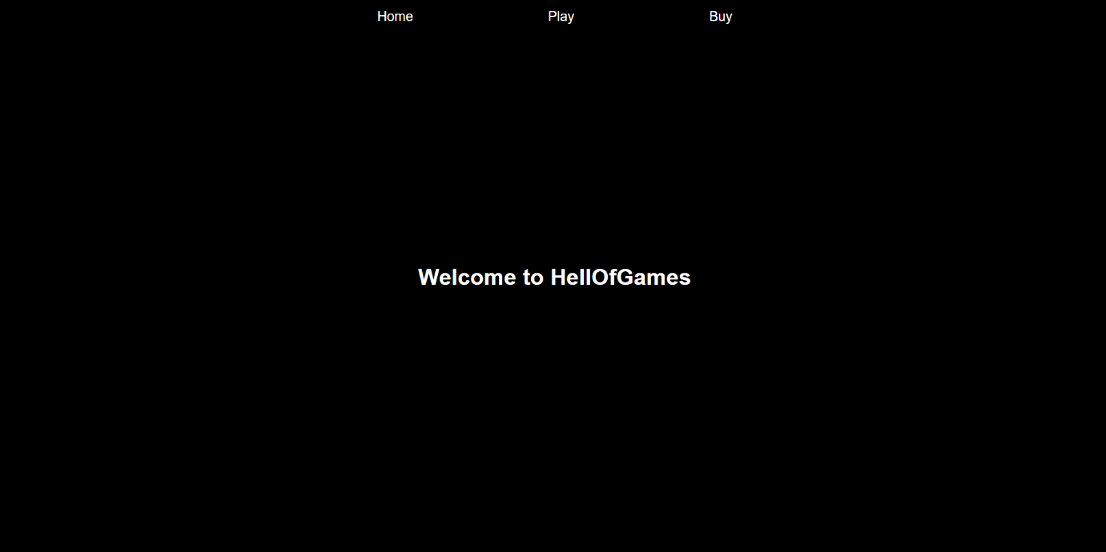

**Play**

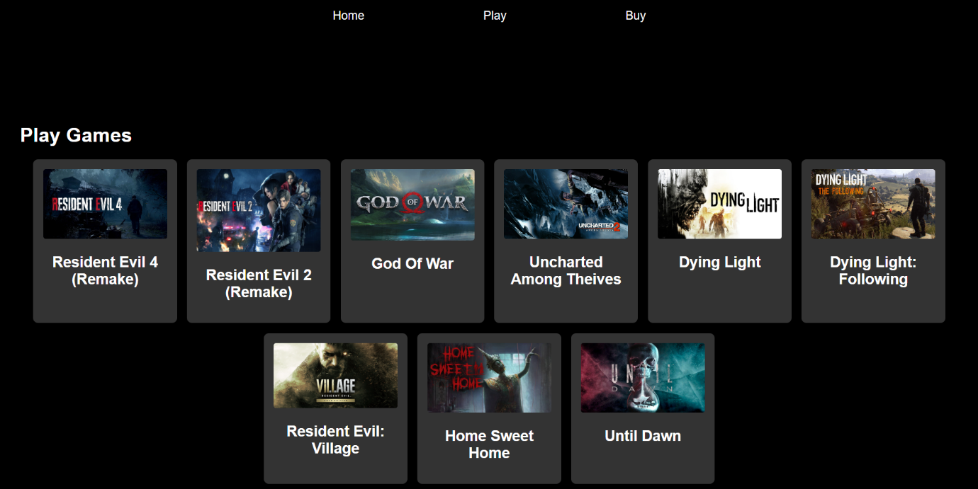

**Buy**

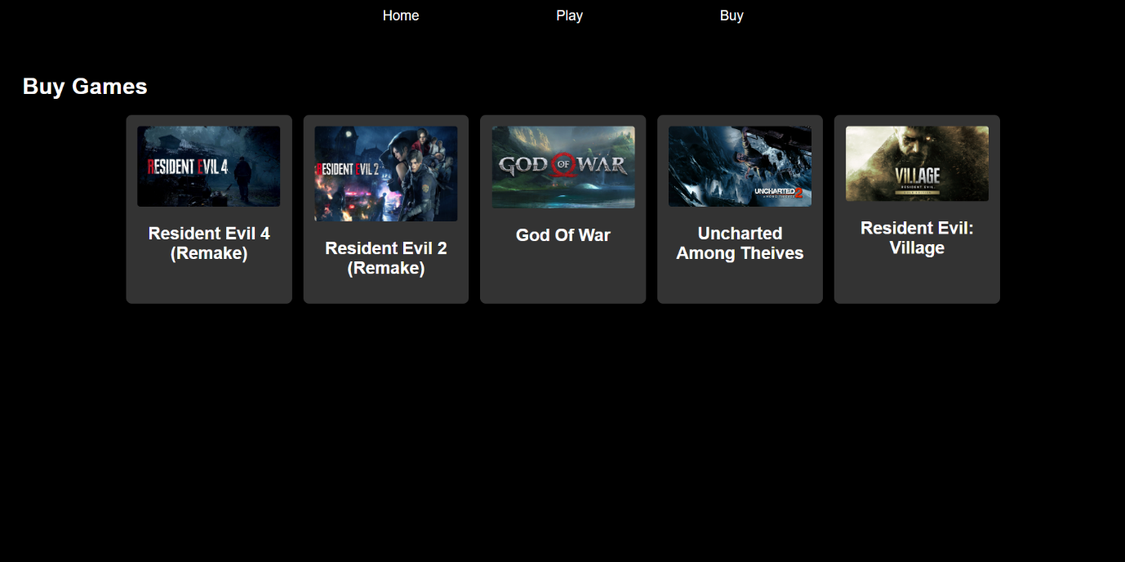

**CONCLUSION: Hence, we have successfully implemented a program which demonstrates React Router and single page applications.**